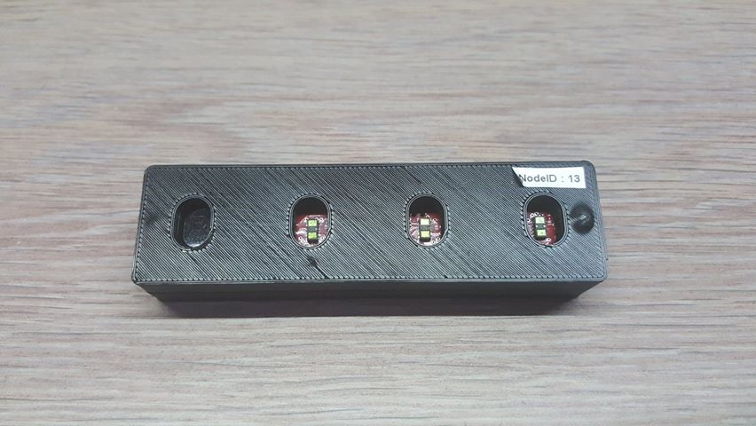**4IR sensor node document**

Summary

I. Introduction 3

1. What is it 3

2. General functioning 3

3. Use of the node 3

II. Performance test 4

1. Test protocol 4

2. Static - Light and Material test 4

3. Static - Angle Target 4

4. Dynamic – Reaction speed 5

III. Conclusion 5

# Introduction

## What is it

The 4IR sensor node is a sensor set mainly composed of a PCB with 4 IR sensors VL53L1X, a microprocessor and a micro USB output. This node is tested to be used in the EDUCAT Project which consists in developing a smart wheelchair for people with reduced mobility.

## General functioning

The node work through an USB connection with his micro USB port. Once the node is supplied by the USB connection, he does not send any data until he receives the string data ‘1’. Then, the node send data as explained below until he receives the string data ‘0’ to come back to the first state. Here is an image of example data received from the node.

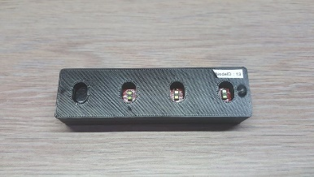

USB connection

Baudrate: 9600 baud

Message : ‘’ID,EC,D,,\r\n’’

ID: a number between 0 and 3 representing which sensor the data comes from.  
EC: an error code explained [her](https://pastebin.com/i7Vb1XxF).  
D: distance in mm.

## Use of the node

In order to collect and process data from the node, a python library has been created and is available by download with pip (“pip install irsensors”). If for any reason you cannot use it, you also have the possibility of created your own program in any language which allows you to read data from USB port.

For the following tests, the library is used with default parameters, i.e. the considered data for each IR sensors in the sensor node are the moving average of the 10 last values received from the USB connection.

# Performance test

## Test protocol

To evaluate the accuracy of the node, several tests had been done on the 4IR sensor node. They are mainly 2 types of tests: static and dynamic.

Static tests: The purpose of these tests is to determinate the accuracy of the sensor node in different conditions, i.e. we wait the datas to be stable, then determinate the accuracy.

Dynamic tests: The purpose of these tests is to determinate the reaction speed of the sensor node.

Light: N(ight – outdoor)/DL(day light – outdoor)/D(ark – indoor)/L(ight on – indoor)

## Static - Light and Material test

This first part is to determinate the influence of the light on the accuracy.  
The data are considered as reliable if the error is less than 5cm.

|  |  |  |  |  |
| --- | --- | --- | --- | --- |
| Target Material | Target Angle | Target colour | Light | Distance range of reliable data |
| Plastic | 0 | Red | L | 5 – 150 cm |
| Plastic | 0 | Red | D | 5 – 150 cm |
| Plastic | 0 | Green | L | 5 – 150 cm |
| Plastic | 0 | Green | D | 5 – 150 cm |
| Glass | 0 | Transparent | L | 5 – 150 cm |
| Glass | 0 | Transparent | D | 5 – 150 cm |
| Concrete | 0 | White | L | 5 – 150 cm |
| Concrete | 0 | White | D | 5 – 150 cm |
| Concrete | 0 | White/grey | DL | 5 – 150 cm |
| Concrete | 0 | White/grey | N | 5 – 150 cm |
| Brick | 0 | Brick | DL | 5 – 150 cm |
| Brick | 0 | Brick | N | 5 – 150 cm |
| Trunk | 0 | Trunk | DL | 5 – 150 cm |
| Trunk | 0 | Trunk | N | 5 – 150 cm |
| Car bodywork | 0 | Black | DL | 5 – 150 cm |
| Car bodywork | 0 | Black | N | 5 – 150 cm |
| Car bodywork | 0 | Blue | DL | 5 – 150 cm |
| Car bodywork | 0 | Blue | N | 5 – 150 cm |

Other Material was tested (Carton, Wood, Fabric, Cotton, Plaster, Metal) and the results were the same.

Because of the IR nature of obstacle detection, neither the ambient brightness nor the material target influences the sensor accuracy

## Static - Angle Target

No matter the angle of the target with respect to the sensor, the accuracy is not influenced while the surface is at least 1 x 1 cm.

## Dynamic – Reaction speed

While the target is in detection range from the sensor, the distance takes about 2 second to be reliable. Caution: if the target moves to fast and get out of the range, the data will be not reliable until a target (same or another) comes back into the range. For example, if a target is at 20cm, goes out of the range so fast that the data cannot follow it, so the data will stay at 20cm until it detects another target. The reason is that if there is no target in the range, the data is not update.

# Conclusion

The IR nature of the sensors detection allows to detect all the material tested if the surface is big enough (1x1cm), not matter the colour or the angle. However, the shape of the object can lead to a difficult detection: for example, a table or a grating can not be detected easily.). Moreover, as the sensor has neither a large range nor a high reaction speed, it should be use at a low speed movement.